 

**IBM PROJECT**

GAS LEAKAGE MONITORING AND ALERTING

SYSTEM FOR INDUSTRIES

**Batch:** B4-4M6E

**Team ID:** PNT2022TMID45387

**Team Leader:** ABDUL AZIZ M

**Team Members:**

►AYYANAR S

►KARTHICK PANDIYAN R

►JEGAN J

CONTENTS

|  |  |
| --- | --- |
| TITLE | **PAGE**  **NUMBER** |
| 1. **INTRODUCTION** | 4 |
| a. Project Overview | 4 |
| b. Purpose | 4 |
| 2. **LITERATURE SURVEY** | 4 |
| a. Existing Problem | 4 |
| b. References | 4 |
| c. Problem Statement Definition | 5 |
| 3. **IDEATION & PROPOSED SOLUTION** | 5 |
| a. Empathy Map Canvas | 5 |
| b. Ideation & Brainstorming | 6 |
| c. Proposed Solution | 8 |
| d. Problem Solution fit | 9 |
| 4. **REQUIREMENT & ANALYSIS** | 10 |
| a. Functional Requirement | 10 |
| b. Non-Functional requirements | 10 |
| 5. **PROJECT DESIGN** | 11 |
| a. Data Flow Diagrams | 11 |
| b. Solution & Technical Architecture | 11 |
| c. User Stories | 12 |
| 6. **PROJECT PLANNING & SCHEDULING** | 13 |
| a. Sprint Planning & Estimation | 13 |
| b. Sprint Delivery Schedule | 13 |
| c. Reports from JIRA | 13 |
| 7. **CODING & SOLUTIONING** | 14 |
| a. Feature 1 | 14 |
| b. Feature 2 | 15 |
| 8. **TESTING** | 15 |
| a. Test Cases | 15 |
| b. User Acceptance Testing | 15 |
| 9. **RESULTS** | 15 |
| a. Performance Metrics | 15 |
| 10. **ADVANTAGES & DISADVANTAGES** | 16 |
| 11. **CONCLUSION** | 16 |
| 12. **FUTURE SCOPE** | 17 |
| 13. **APPENDIX** | 17 |
| Source Code | 17 |
| GitHub & Project Demo Link | 17 |

**1.INTRODUCTION**

**1.1 Project Overview:**

This project helps the industries in monitoring the emission of harmful gases. In several areas, the integration of gas sensors helps in monitoring the gas leakage. If in any area gas leakage is detected the admins will be notified along with the location. In the web application, admins can view the sensor parameters.

**1.2 Purpose:**

Inhaling concentrated gas can lead to asphyxia and possible death.To overcome these disasters, we designed a system for monitoring and alerting the leakage of those harmful gases. This makes the industrialists get rid of the fear of any disasters caused by the gases.

**2. LITERATURE SURVEY**

**2.1 Existing Problem:**

This scheme is meant to fulfill the daily needs of the people. In our country 40 percent people die due to gas explosion at home. That number keeps growing. Even pregnant women and small children are affected.Using a GSM module and a mobile phone, the Gas Leakage Monitor is used to find, intimate leaks. The buzzer and LED are then activated after the gas leak is detected using a bracket sensor. When the designated time has passed, it will automatically turn off.

**2.2 References:**

[1] Shital Imade, Priyanka Rajmane, Aishwarya Gavali, V. N. Nayakwadi “Review paper on- LPG Gas leakage detection using IOT”: IJIRS –International Journal of Innovative Research & Studies, Volume 8, Issue 2, Feb 2018 IJIRS: ISSN NO: 2319-9725. [2] Gas Leakage Detection Based on Arduino And Alarm Sound, Rhonnel S. Paculanan, Israel Carino, International Journal of Innovative Technology and Exploring Engineering (IJITEE) Vol 8, April 2019. [3] Dr. Chetana Tukkoji, Mr. Sanjeev Kumar, “Review paper on- LPG Gas leakage detection using IOT”: IJEAST –International Journal of Engineering Applied Science & Technology, Volume 4, Issue 12, April 2020 IJEAST (online): 603-609. [4] Sanjoy Das, Sahana S, Soujanya K Swathi M C, "Gas leakage detection and prevention using IoT", International Journal of Scientific Research % Engineering Trends. Vol 6, Issue 3, May-June 2020, ISSN (online): 2395-566X. [5] Amatul Munnaza, Rupa Tejaswi, Tarun Kumar Reddy, Saranga Moahan “IoT Based Gas Leakage Monitoring Syste”, Journal of Xi’an University of Architecture & Technology,Vol 12, ISSN No: 1006-7930, Issue 5, 2020. [6] B. F. Alshammari, M. T. Chughtai, “IoT Gas leakage detector and warning generator”. Engineering and Technology and Applied Science Research Volume 10, Issue August 2020 .6142-6146. [7] Gas Leakage Detection and Prevention System, Shreyas Thorat, Neha Tonape, International Journal of Trendy Research, Vol 4, Issue 7, Dec 2020, ISSN NO: 2582-0958. [8] Rohan KH1, Navanika Reddy, Pranamya Maddy, Sachit Girish, Dr. Badari Nath K “IOT based gas leakage detection and Alerting system”: JRP Publications,Vol. 1(1), pp. 002-006, February 2021. [9] D. Surie, O. Laguionie, T. Pederson, “Wireless sensor networking of everyday objects in a smart home environment”, Proceedings of the International Conference on Intelligent Sensors”, Sensor Networks and Information Processing?ISSNIP- 2008, pp. 189 – 194. REFERENCE: [10] J. Tsado, O. Imoru, S.O. Olayemi, “Design and construction of a GSM based gas leak Alert system”‖, IEEE Transaction,IRJEEE Vol. 1(1), pp. 002-006, September, 2014. [11] M. Eisenhauer, P. Rosengren, P. Antolin, “A Development Platform for Integrating Wireless Devices and Sensors into Ambient Intelligence Systems”, pp.1- 3. [12] Harshada Navale, Prof. B.V.Pawar, “Arm Based Gas Monitoring System”. International Journal of Scientific & Technology Research Volu me 3, Issue 6, June 2014. [13] Byeongkwan Kang,Sunghoi Park,Tacklim Lee andSehyun Park, "loT?based Monitoring System using Tri-level Context Making Model for Smart Home Services", 2015 IEEE International Conference on Consumer Electronics (ICCE), 2015. [14] Abhishek, P. Bharath, “Automation of lpg cylinder booking and leakge monitoring system,” International Journal of Combined Researchand Development (IJCRD), pp. 693–695, 2016

**2.3 Problem statement definition:**

This device does not get damaged very quickly, and if it does get damaged, water is the main reason for it. This device is easily damaged by water. Therefore, this device should be installed in a place where water does not go. This installation will not damage the device, if the device does, an example is water.

This tool is considered to be one and very safe for the users. My members are trusted. My members' invention is considered very safe for this country and its people and their families. Absence of this tool makes women in our country nervous by the spread of gas in their kitchen and is considered to be a sign of some accident. It is also proud to think of this project for people's lives only to eliminate this fear.

**3. IDEATION & PROPOSED SOLUTION:**

**3.1 Empathy Map Canvas:**

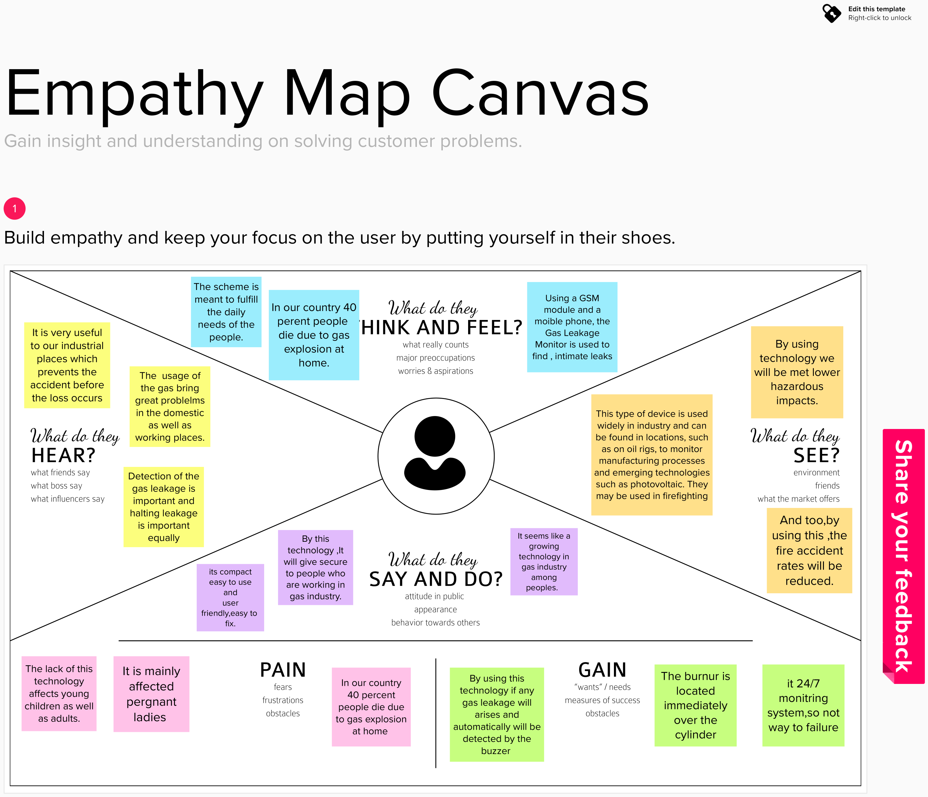

**3.2 Ideation & Brainstorming:**

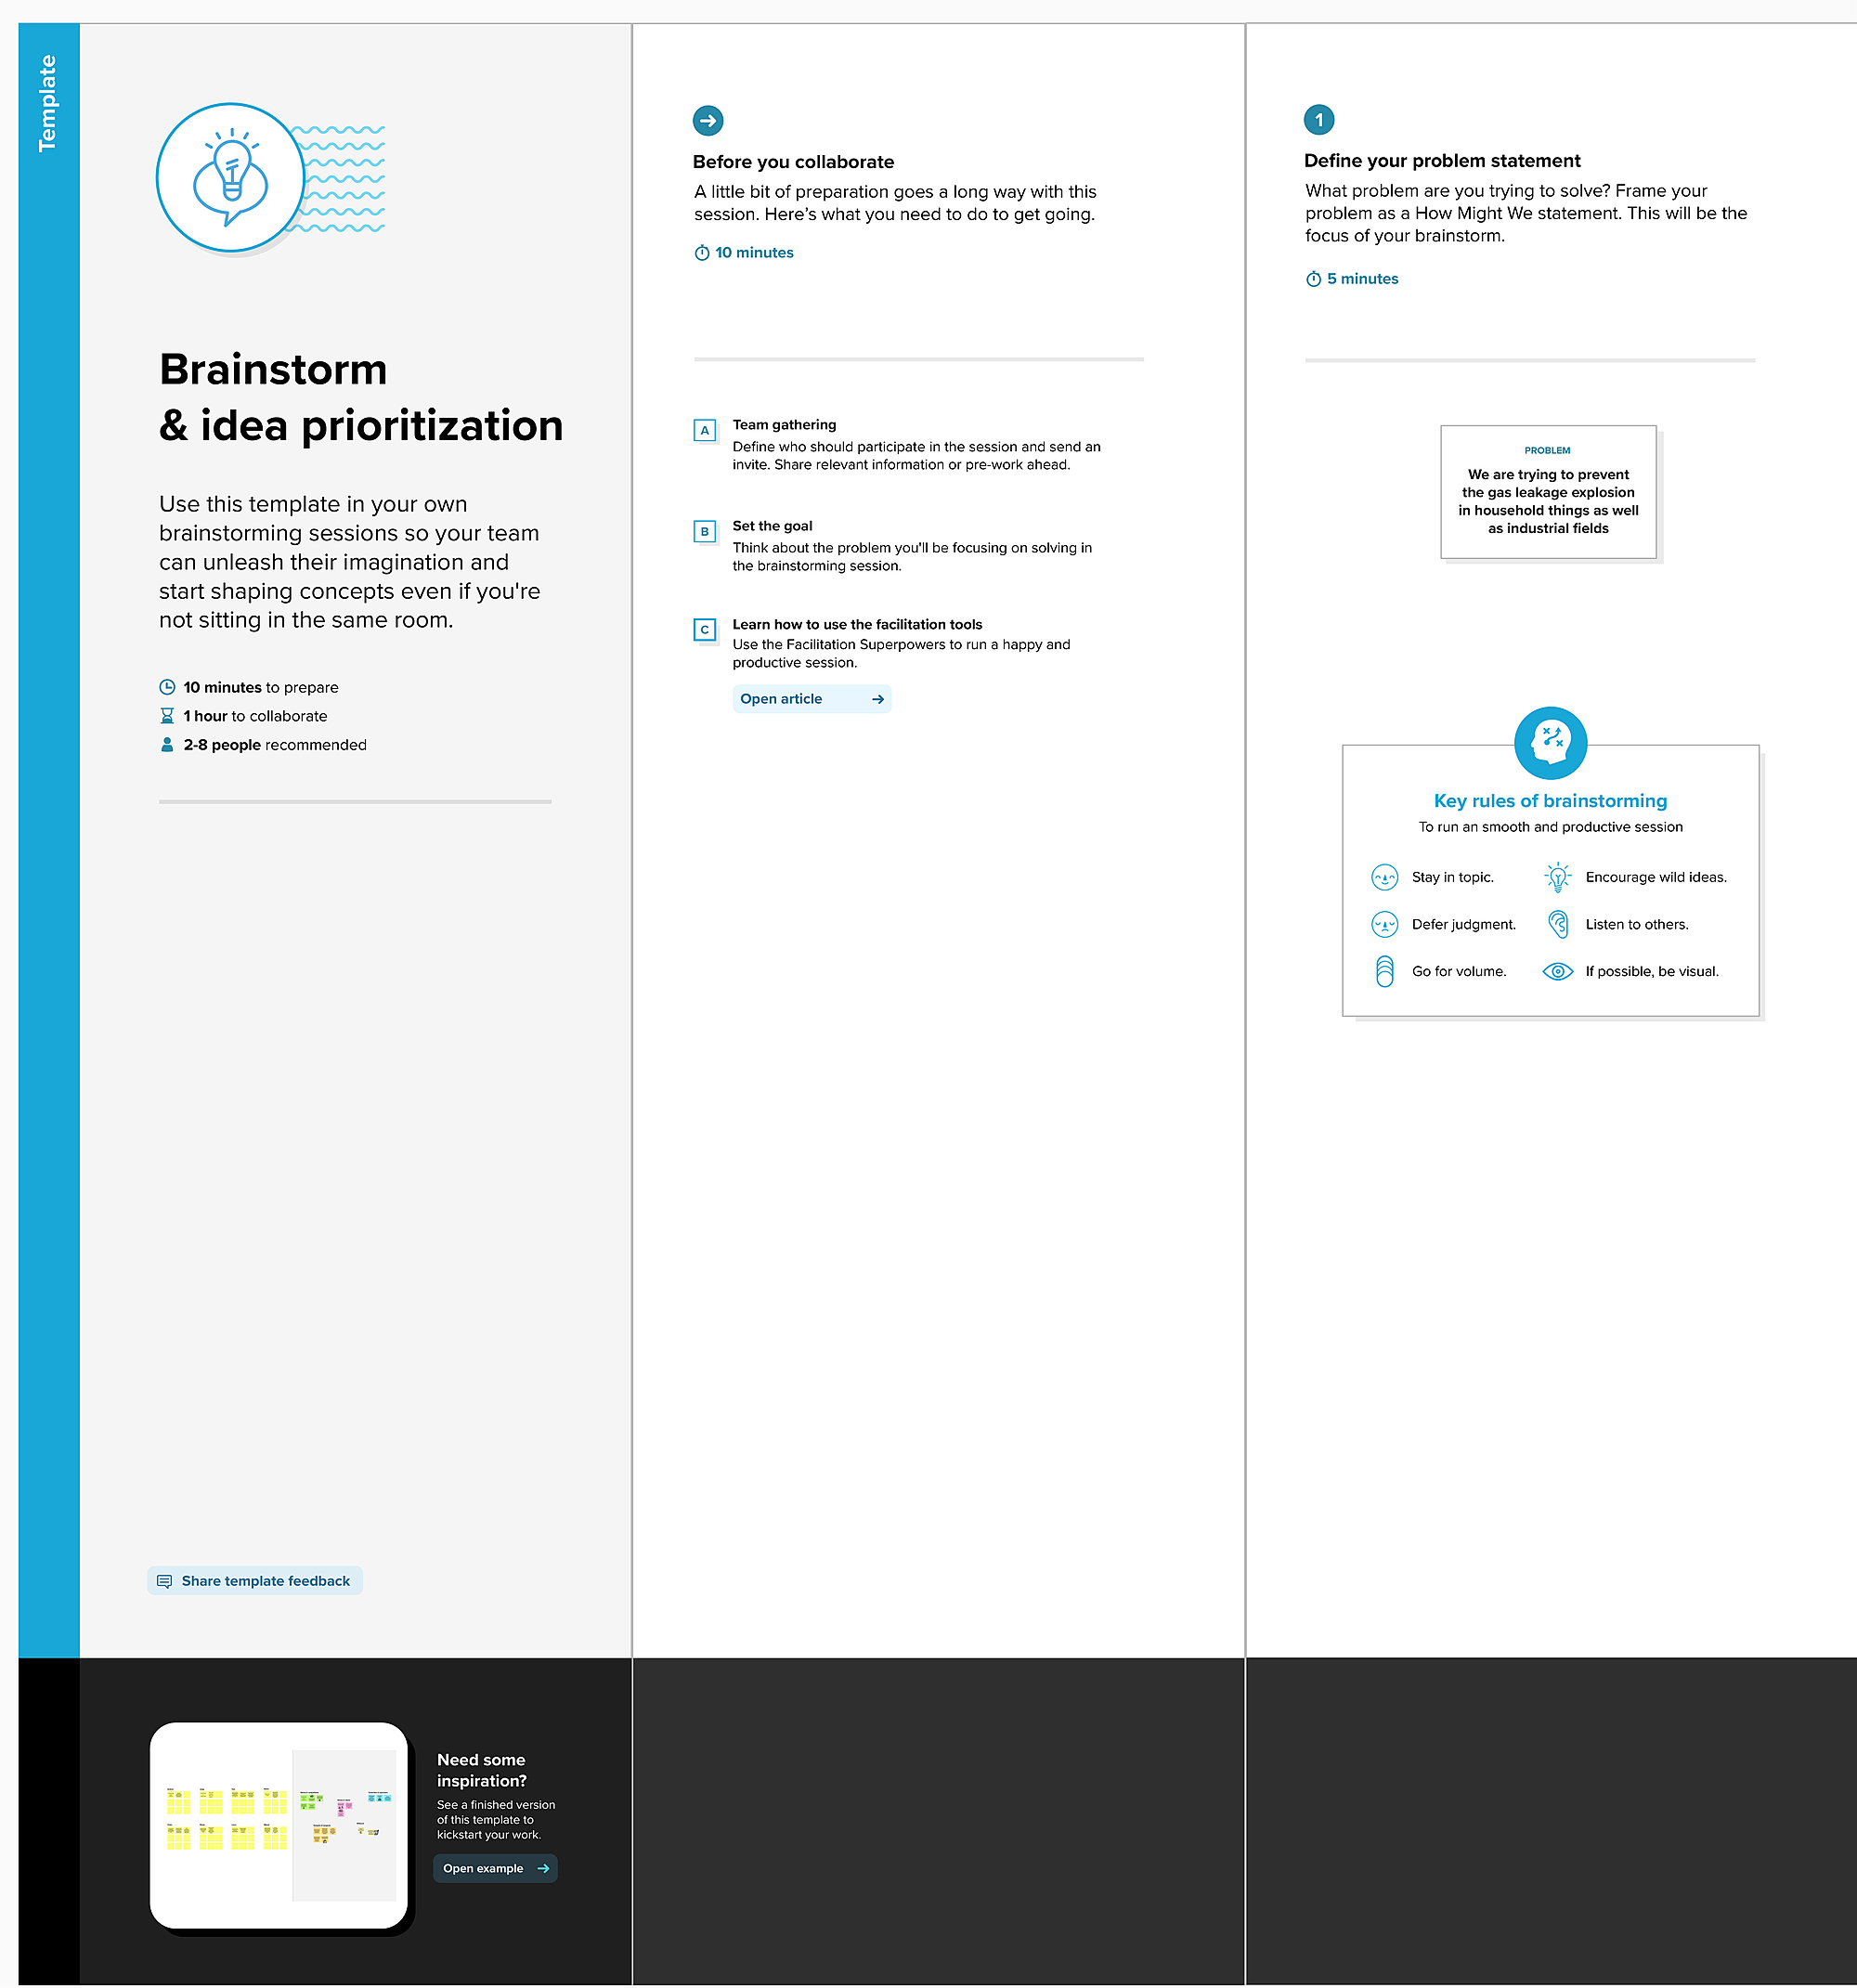

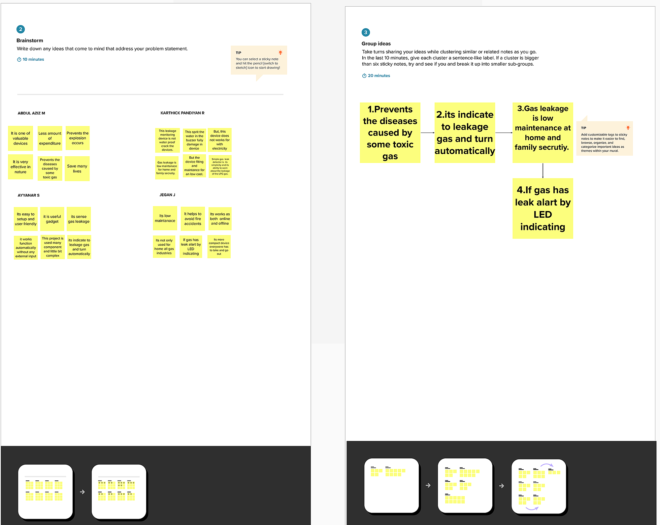

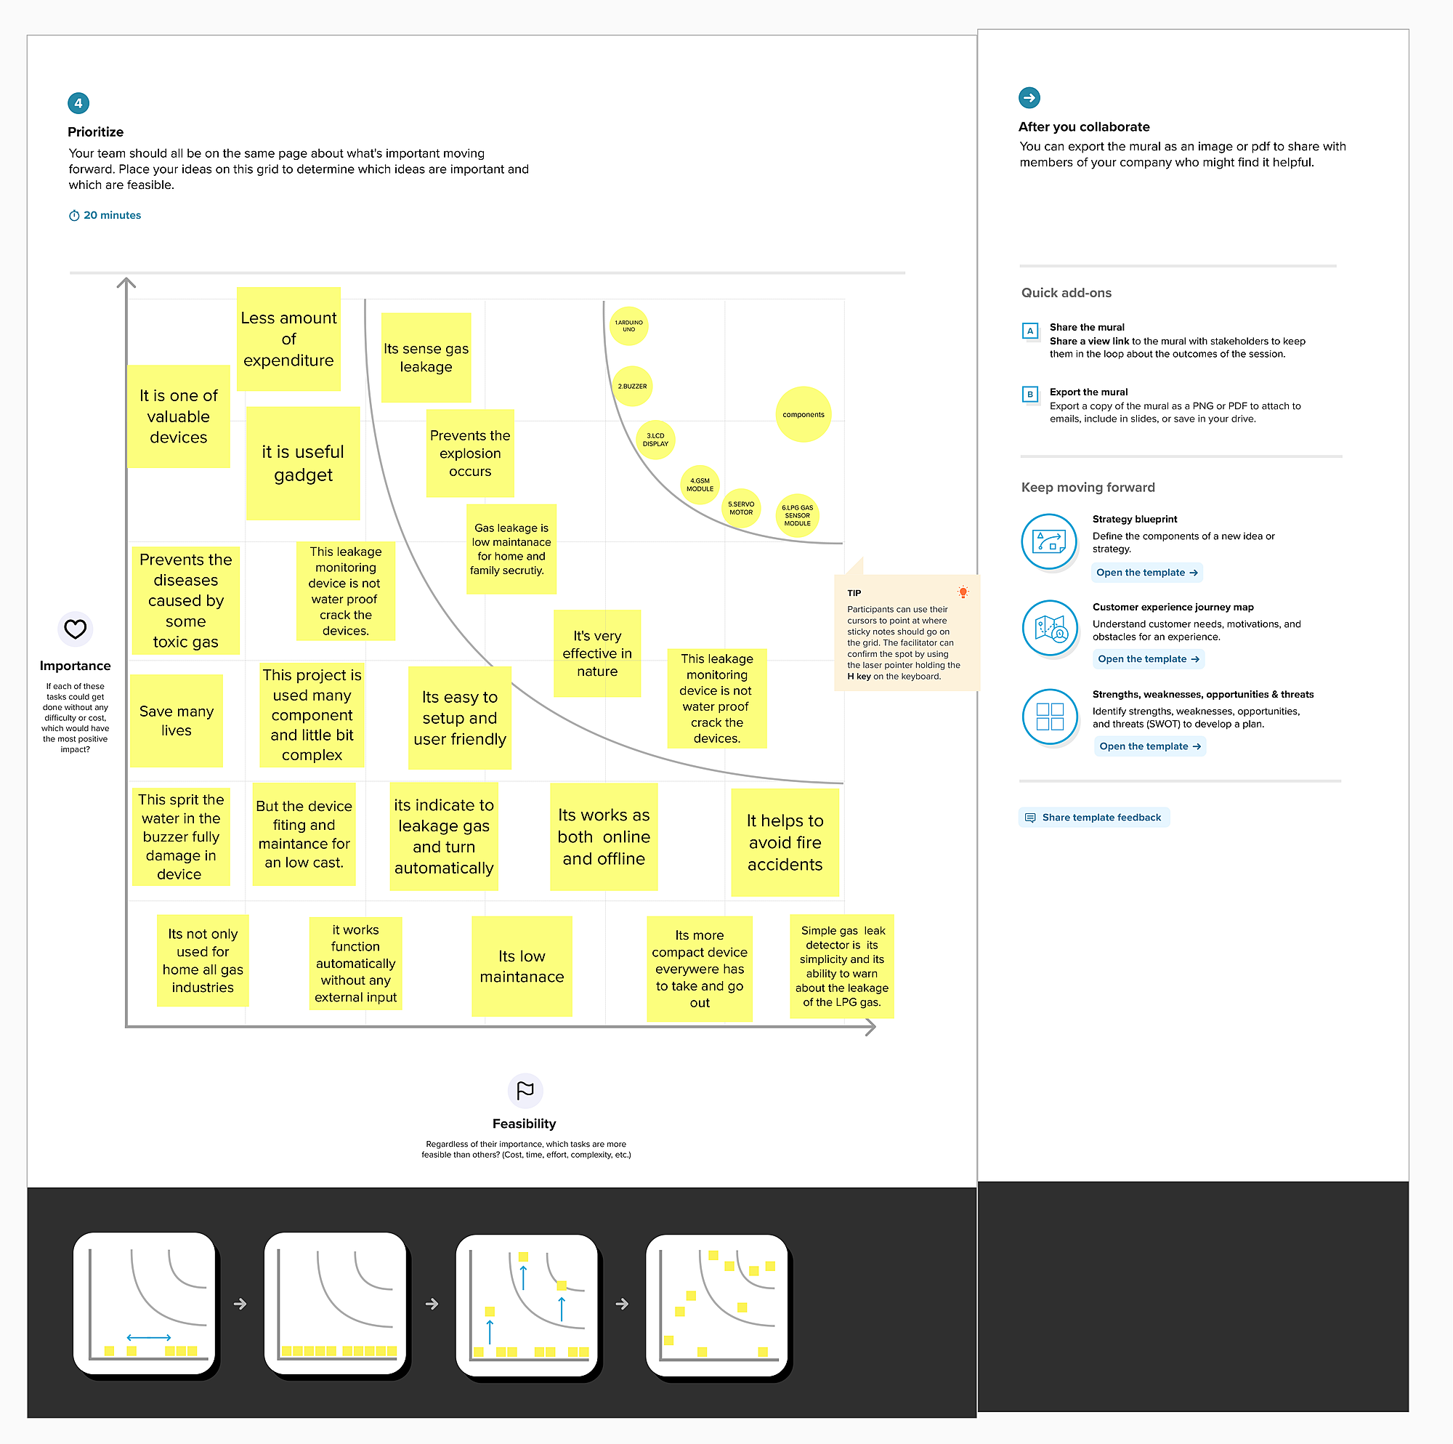

**3.3 Proposed Solution:**

|  |  |  |
| --- | --- | --- |
| **S.NO** | **Parameter** | **Description** |
| **1.** | Problem Statement (Problem to be solved) | This monitoring is used to prevent fire accidents due flammable gas leakage in house from cylinders,industries,hospitals,hotels etc. |
| **2.** | Idea / Solution description | This monitoring system uses cloud and iot based hard wares and sensors.The sensors in the system detects flammable gaseous components in the environment and temperature using iot system and send indication via alarms and lights. |
| **3.** | Novelty / Uniqueness | The uniqueness of this system is that it uses cloud due to this, the alarm can be to the person via sms to his mobile when he is not in home. |
| **4.** | Social Impact / Customer Satisfaction | It helps in many ways to the society it prevents fire accidents due careless handle of gas cylinders . this is a real-time systems so it is faster and accidents can be prevented very easily. |
| **5.** | Business Model (Revenue Model) | This is a cloud based real time system ,that collects the data from the environment very quickly i.e. temperature,humidity and oxygen composition. using sensors and indicate via alarms and lights. |
| **6.** | Scalability of the Solution | ● Accuracy.   Low cost.   Less maintenance.   Reliability. |

**3.4**  **Problem Solution Fit:**

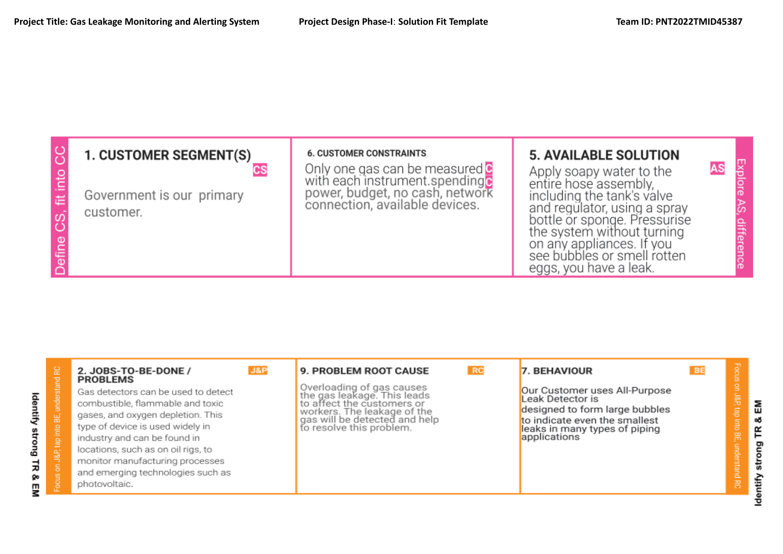

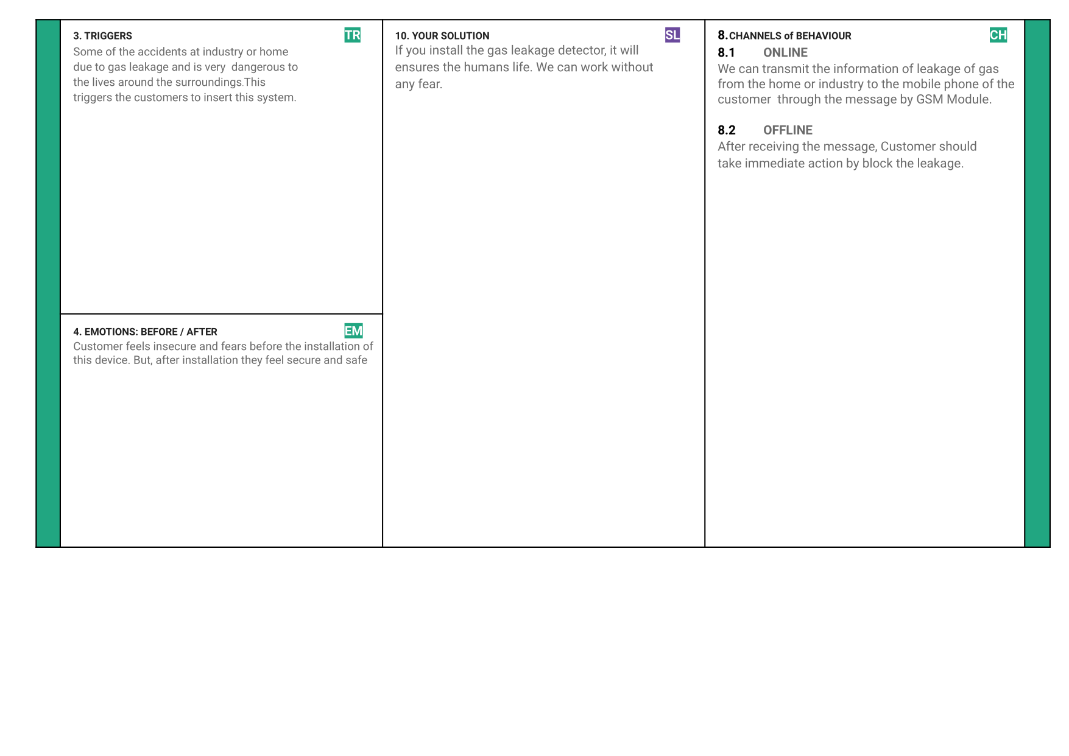

**4. REQUIREMENT ANALYSIS**

**4.1 Functional Requirement:**

|  |  |  |
| --- | --- | --- |
| **FR No.** | **Functional Requirement (EPIC)** | **Sub Requirement (Story / Sub-Task)** |
| FR-1 | Create cloud account | Registration through Form Registration through G mail Registration through Link |
| FR-2 | User Confirmation | Confirmation via Email Confirmation via OT |
| FR-3 | User Login | User Login Via Mail id And Password |
| FR-4 | Cloud registration | Connect the hardware device |
| FR-5 | Connect to mobile | Connect the cloud with the mobile phone |
| FR-6 | Connect Hardware | Connect hardware to the gas cylinders or in the wall |

**4.2 Non-functional Requirements:**

|  |  |  |
| --- | --- | --- |
| **FR No.** | **Non-Functional Requirement** | **Description** |
| NFR-1 | Usability | * It is user friendly * Easy to handle * Process is simple |
| NFR-2 | Security | * The device is highly secure. * Privacy is maintained |
| NFR-3 | Reliability | * The device is more reliable * The device is more trustable in tough conditions |
| NFR-4 | Performance | * The performance is more accurate. * It is a real time application |
| NFR-5 | Availability | * It can be available easily. * It requires very few hardware components. |
| NFR-6 | Scalability | * Less maintenance. * Low cost. * Compact. |

**5. PROJECT DESIGN:**

**5.1 Data Flow Diagrams:**

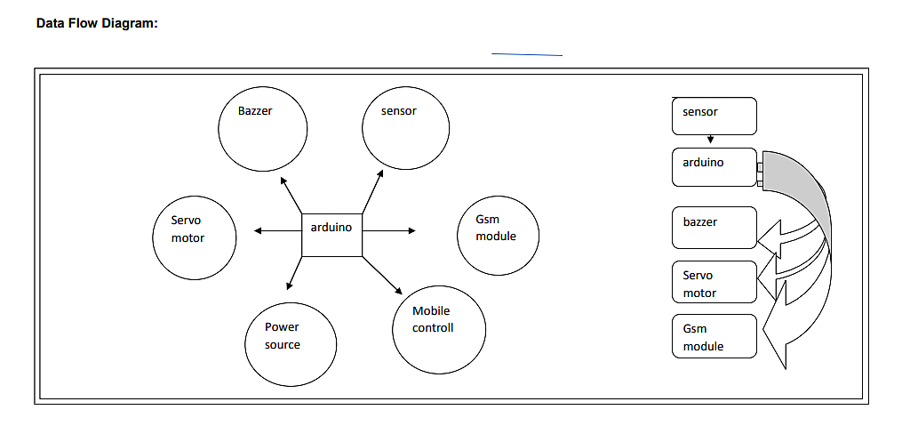

**5.2 Solution & Technical Architecture:**

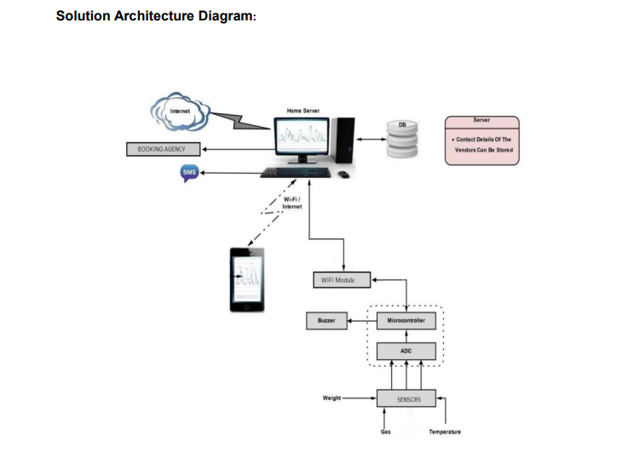

**5.3 User Stories:**

|  |  |  |  |  |  |  |
| --- | --- | --- | --- | --- | --- | --- |
| **User Type** | **Functional Requirement (Epic)** | **User Story Number** | **User Story / Task** | **Acceptance criteria** | **Priority** | **Release** |
| Customer (Mobile user) | Registration | USN-1 | As a user, I can register for the application by entering my email, password, and confirming my password. | I can access my account / dashboard | High | Sprint-1 |
|  |  | USN-2 | As a user, I will receive confirmation email once I have registered for the application | I can receive confirmation email & click confirm | High | Sprint-1 |
|  |  | USN-3 | As a user, I can register for the application through Facebook | I can register & access the dashboard with Facebook Login | High | Sprint-2 |
|  |  | USN-4 | As a user, I can register for the application through Gmail | I can access by message | Medium | Sprint-1 |
|  | Login | USN-5 | As a user, I can log into the application by entering email & password | No need to login mail id | High | Sprint-1 |
| Customer (Web user) | Dashboard |  |  |  |  |  |
| Customer Care Executive | Registeraion | USN-1 | User want to use sim card and gsm module | Message reciver for arduino connected sim | High | Sprint-1 |
|  |  | USN-1 | Sensor and module | All component is connected to arduino | High | Sprint-1 |
| Administrator | DATA | USN-1 | What is Main component in this project | Arduino | High | Sprint-2 |
|  |  |  |  |  |  |  |
| power | Dc | USN-1 | How much power is required | 9v is enff | High | Sprint-1 |
|  |  |  |  |  |  |  |

**6. PROJECT PLANNING AND SCHEDULING:**

**6.1 Sprint Planning & Estimation:**

|  |  |  |  |  |  |  |
| --- | --- | --- | --- | --- | --- | --- |
| **Sprint** | **Functional Requirement (Epic)** | **User Story Number** | **User Story / Task** | **Story Points** | **Priority** | **Team Members** |
| Sprint-1 | Data Preparation & Data Visualization | USN-1 | As a user, I provide Safety to the customers | 5 | High | Karthick pandiyan R |
| Sprint-1 |  | USN-2 | As an Analyst, I collect the data & Provide meaningful insights through IBM Cloud | 3 | High | Jegan J |
| Sprint-2 | Dashboard | USN-3 | As a user, I want to make sure the safe environment. | 3 | High | Ayyanar S |
| Sprint-2 |  | USN-4 | As an Analyst, I will upload the data in IBM Cloud to createa interactive dashboard | 3 | Medium | Abdul Aziz M |
| Sprint-3 | Report | USN-5 | As a user, I want to secure the lives and data of each employee that report a particular event | 3 | Medium | Karthick pandiyan R |
| Sprint-3 |  | USN-6 | As an Analyst, I will use IBM Cloud to generate a report | 3 | Medium | Jegan J |
| Sprint-4 | Story | USN-7 | As a user, I can only understand the Analysis in animated presentation of dataset | 5 | Medium | Ayyanar S |
| Sprint-4 |  | USN-8 | As an Analyst, I use IBM to create an animated presentation (Story) of the dataset | 3 | High | Abdul Aziz M |

**6.2 Sprint Delivery Schedule:**

|  |  |  |  |  |  |  |
| --- | --- | --- | --- | --- | --- | --- |
| Sprint | Total Story Points | Duration | Sprint Start Date | Sprint End Date (Planned) | Story Points Completed (as on Planned End Date) | Sprint Release Date (Actual) |
| Sprint-1 | 5 | 6 Days | 24 Oct 2022 | 24 Oct 2022 | 5 | 29 Oct 2022 |
| Sprint-2 | 5 | 6 Days | 31 Oct 2022 | 05 Nov 2022 | 5 | 05 Nov 2022 |
| Sprint-3 | 5 | 6 Days | 07 Nov 2022 | 12 Nov 2022 | 5 | 12 Nov 2022 |
| Sprint-4 | 5 | 6 Days | 14 Nov 2022 | 19 Nov 2022 | 5 | 15 Nov 2022 |

**Velocity:**

We have an 6-day sprint duration, and the velocity of the team is 4 (points per sprint). To

calculate the team’s average velocity (AV) per iteration unit (story points per day

SPRINT DURATION 6

AV = _________________________________________ = _________ = 1.5

VELOCITY 4

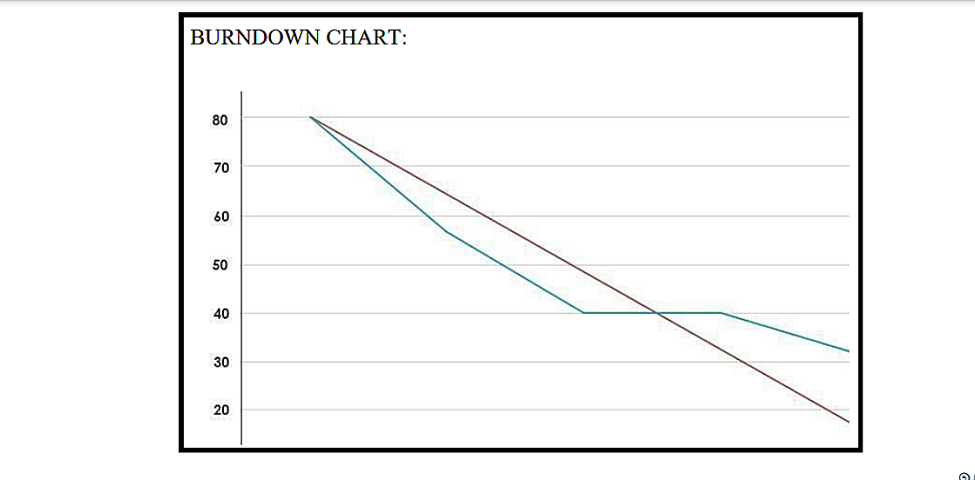

**7. CODING AND SOLUTIONING:**

**7.1 Feature 1(Node Red Output)**

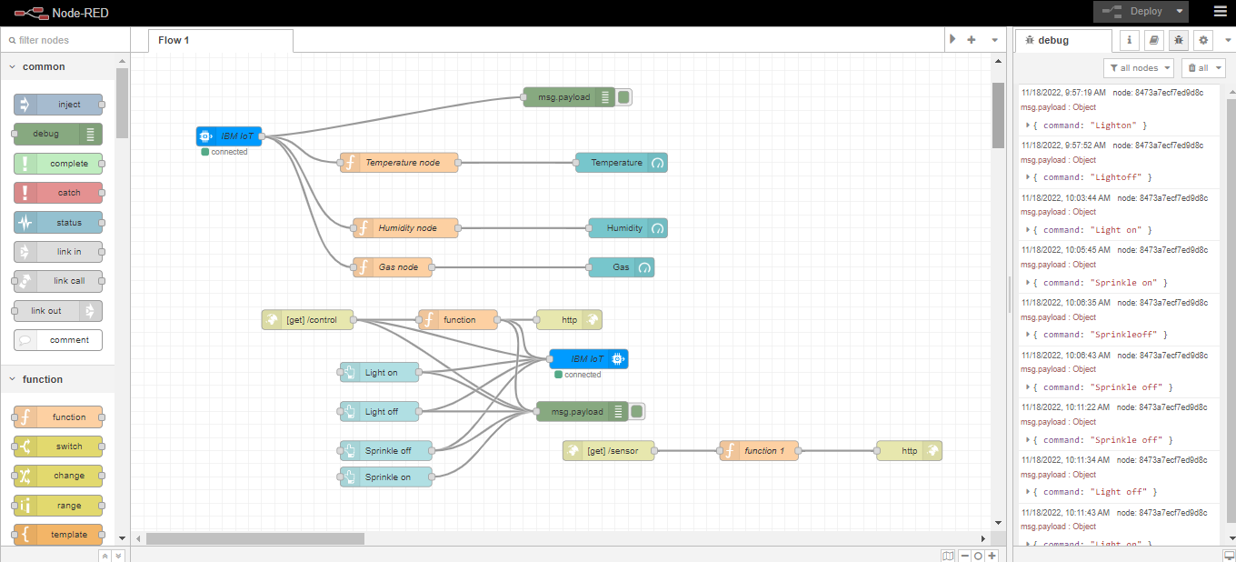

**7.2 Feature 2: (Python Output)**

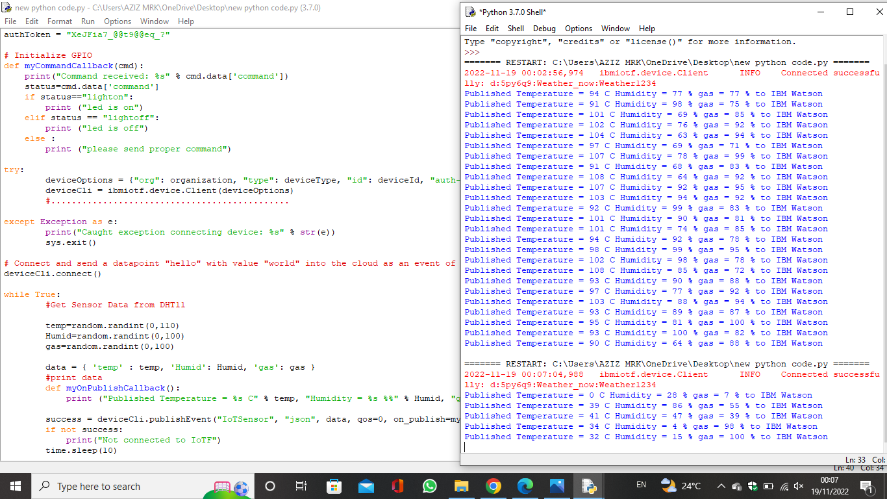

**8. TESTING:**

**8.1 [Test cases:](https://docs.google.com/spreadsheets/d/1-zmHckuq-SKwN2kIEkBfHRJvKKzteVUk/edit#gid=583695023)**

**[8.2](https://docs.google.com/spreadsheets/d/1-zmHckuq-SKwN2kIEkBfHRJvKKzteVUk/edit#gid=583695023) [User Acceptance Testing](https://docs.google.com/document/d/1LRCRmq1xSbINhW-MNFTvNolr47A7Sbc0BIKm61DrhHw/edit):**

**9. RESULTS:**

**9.1 [Performance Testing:](https://docs.google.com/spreadsheets/d/1NCyGVCh706FDG_GKgtlxa69ms9W-NruA/edit#gid=1881962193)**

**10. WEB APPLICATION DASHBOARD:**

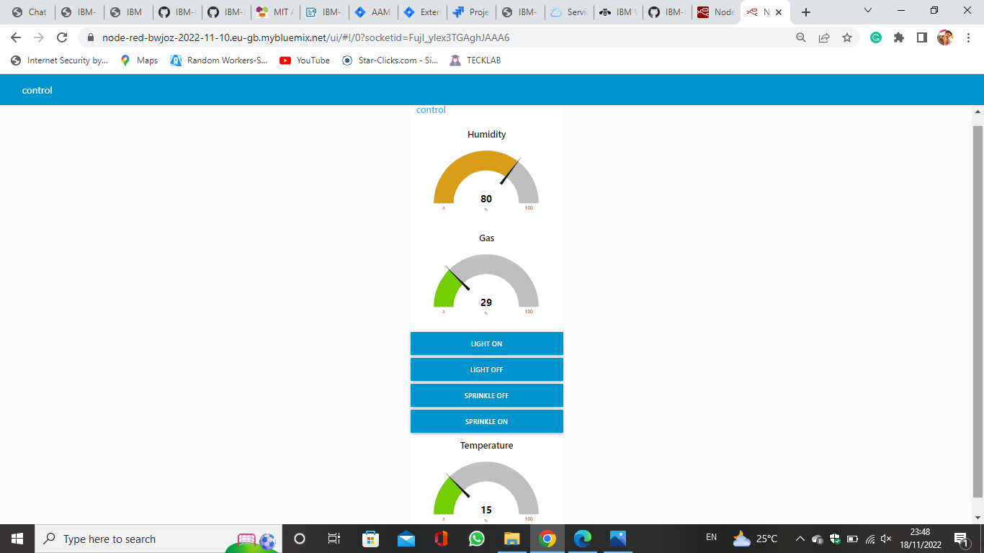

**11.ADVANTAGES AND DISADVANTAGES**

**Advantages:**

* + Detect the concentration of the gases
  + The sensor-enabled solution helps prevent the high risk of gas explosions and affecting any casualties within and outside the premises.
  + Get real-time alerts about the gaseous presence in the atmosphere
  + Prevent fire hazards and explosions
  + Ensure worker’s health
  + Real-time updates about leakages
  + Cost-effective installation
  + Measure oxygen level accuracy
  + Get immediate gas leak alerts

**Disadvantage:**

* + - Get immediate gas leak alerts
    - When heavy dust, steam or fog blocks the laser beam, the system will not be able to take measurements

**12. MOBILE APPLICATION:**

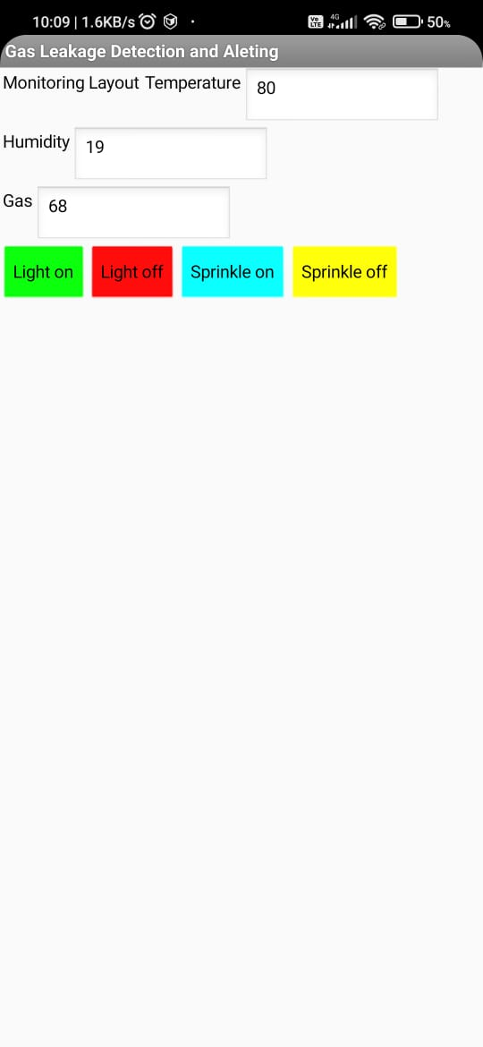

**13.CONCLUSION:**

Gas leakage leads to severe accidents resulting in material losses and human injuries.Gas leakage occurs due to poor maintenance of equipment and inadequate awareness of the people. Hence, gas leakage detection is essential to prevent accidents and to save human lives. This paper presented LPG leakage detection and alert system. This system triggers buzzer and notification to alert people when gas leakage is detected. This system is basic yet reliable.

**14. FUTURE SCOPE:**

Major cities of India are pushing Smart Home application, gas monitoring system is a part of SmartHome application. Enhancing Industrial Safety using IoT. This system can be implemented in Industries, Hotels and wherever the gas cylinders are used. This system can be used in industries involving applications such as Furnace, Boilers, Gas welding, Gas cutting, Steel Plants, Metallurgical industries, Food processing Industries, Glass Industries, Plastic industries, Pharmaceuticals, Aerosol manufacturing. As hospitals require to provide maximum possible safety to patients, this system can be used to keep track of all the cylinders used in it. Some of the cylinders used are Oxygen cylinder, Carbon dioxide cylinder, Nitrous oxide cylinder. As many students are naive the risk of causing accidents is high. Hence, our system can also be used in schools, colleges. Many colleges have well established labs including chemistry lab and pharmaceutical labs where gas burners are used. Several medical equipment requires gas cylinders.

**15. APPENDIX:**

**Source Code:**

* + - **[Source code](https://github.com/IBM-EPBL/IBM-Project-30133-1660140562/tree/main/Final%20Deliverables/Source%20code)**

**GitHub and Project Demo Link:**

* + **[GitHub link](https://github.com/IBM-EPBL/IBM-Project-30133-1660140562)**
  + **[Project Demo Link](https://github.com/IBM-EPBL/IBM-Project-30133-1660140562/tree/main/Final%20Deliverables/Demo%20link)**